# **General Skeleton**

## **Purpose of static in public static void main()**

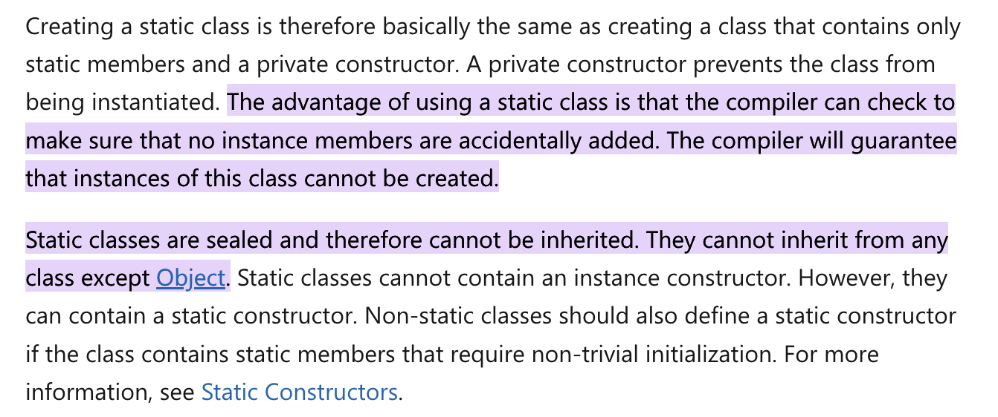

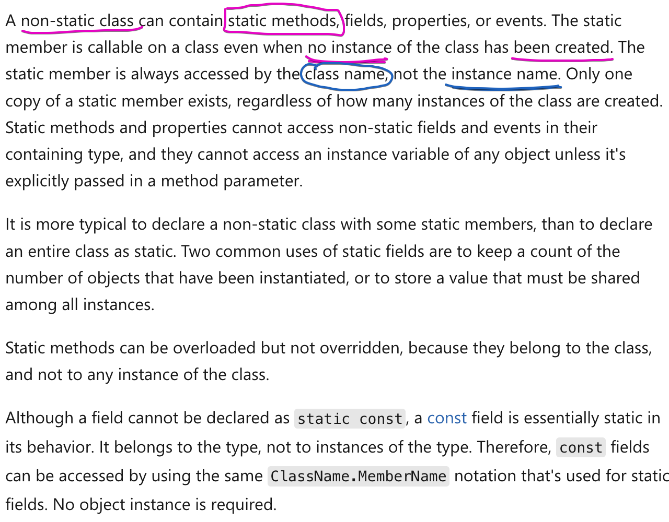

# **Reading the inputs**

**Refer program2.java**

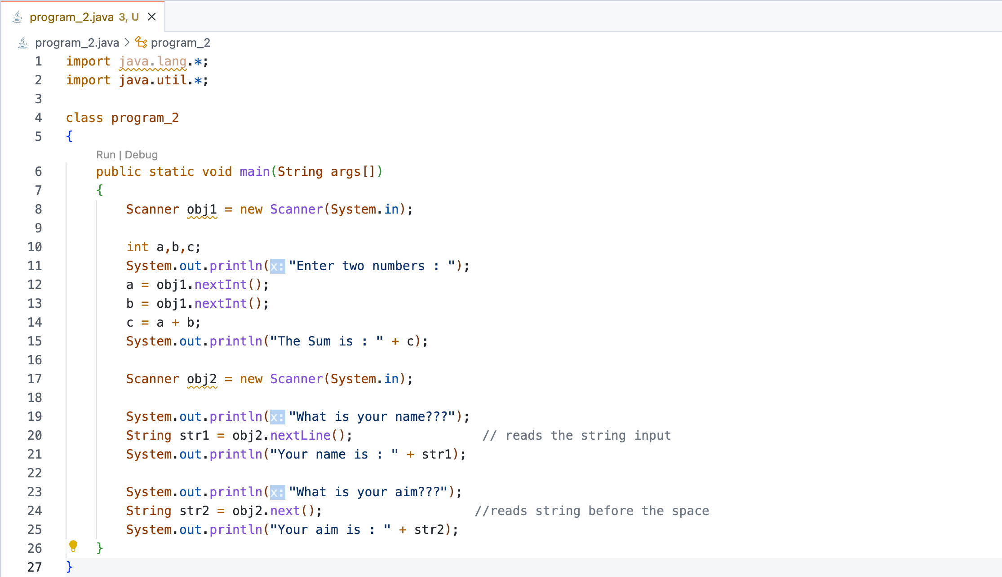

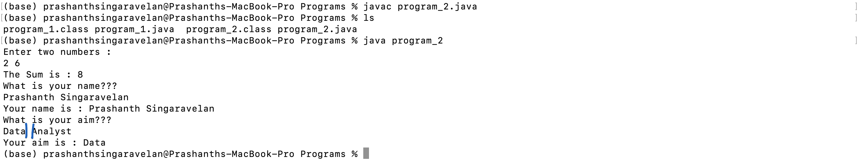

# **References**

<https://www.udemy.com/course/java-se-programming/>

<https://docs.microsoft.com/en-us/dotnet/csharp/programming-guide/classes-and-structs/static-classes-and-static-class-members>